Movie Browser Server
Operations Requirement Document

Version: 1.1

Copyright © <2009>, TeleNav, Inc.
All rights reserved.

Revision History
Version | Date of Issue | Remarks | Revised by
1.0 | 12-03-2009 | Initial Draft | Zongyong Wang

Requests Deadlines
Date | Request Items | Deadline | Correspondence
Table of Contents
Revision History 2
Requests Deadlines 2
1 Synopsis 4
2 Contact Information 4
3 Architecture Diagram 4
3.1 Sequence Flow 5
4 System Capacity 5
5 Logging 5
5.1 File Based Logging 5
5.2 CLI Based Logging 5
6 Implementation 6
6.1 Hardware Requirements 6
6.1.1 Testing Environment (Test @ US) 6
6.1.2 Staging Phase (Staging @ US) 6
6.1.3 Production Phase (Production @ US) 6
6.2 Software Packages 6
6.3 Load Balancing 7
6.4 Database Installation Procedures 7
6.4.1 Install mysql 7
6.4.2 Create temp tables 7
6.5 Browser Server Installation Procedures 7
6.5.1 Create folder 7
6.5.2 Setup dispatcher application 7
6.5.3 Setup Movies application 8
6.5.4 Setup cron job for Movies Feed receiver 8
6.6 Operation Procedures 8
6.6.1 Start up Instructions 8
6.6.2 Shutdown Instructions 8
6.7 Verification Procedures 8
6.8 Roll Back Procedures 8
7 Monitoring Application 9
7.1 Application Monitoring Big Brother 9
7.2 Application Monitoring Little Brother 9
7.3 Heartbeat Monitoring 9

Synopsis

This system is to add movie searching feature for ATT1.7 navigation users. It is based on browser server 2.0 framework. And we also need add a dispatcher server.

Contact Information

 | Name | Email | Phone Number
Primary | Wei Lai | lwei@telenav.cn
Secondary | Zongyong | zywang@telenav.cn

Architecture Diagram

Figure 1 Overall Architecture of Movie Browser Server System
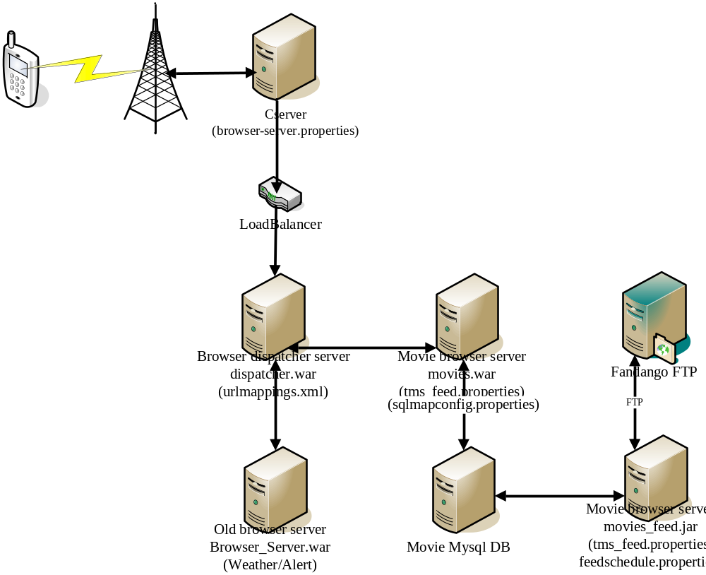

Sequence Flow
Figure 2 Sequence Flow
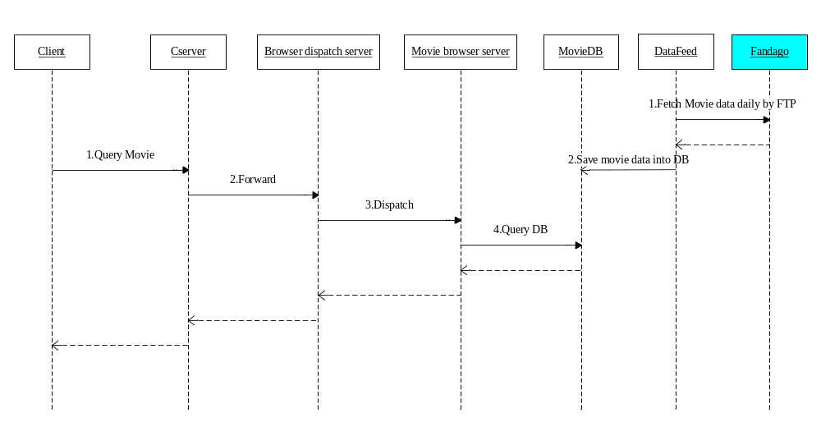

System Capacity

Logging

File Based Logging
Item | Details
Log Path | \home\tnuser\logs\browser\dispatcher.log  \home\tnuser\logs\browser\movies\browser.log  \home\tnuser\logs\browser\movies\movie_feed_mis.log
Log Rolling Plan | Daily
On-line System | 1 month
System off-line or decommissioned

CLI Based Logging

Implementation

Hardware Requirements

Testing Environment (Test @ US)
RAM | >= 8G
HDD | >= 200 GB
CPU | >= 2.0 GHz

Staging Phase (Staging @ US)
RAM | >= 8G
HDD | >= 200 GB
CPU | >= 2.0 GHz

Production Phase (Production @ US)
Two 64 bit servers running Linux OS for tomcat:
RAM | > 4G
HDD | >= 200 GB
CPU | >= 2.0 Giga

Two 64 bit server running mysql DB(One master, one slave):
RAM | > 4G
HDD | >= 200 GB
CPU | >= 2.0 Giga

Software Packages

Standard Packages:
JDK 1.6
Tomcat 6.0
Mysql

Release package name:

movies.war
dispatcher.war
movies_feed.zip

Release package folder:
\\media1.telenav.com\Release\TN\TeleNav5.0\browser-server\browser20\dispatcher_server
\\media1.telenav.com\Release\TN\TeleNav5.0\browser-server\browser20\movies
\\media1.telenav.com\Release\TN\TeleNav5.0\browser-server\browser20\movies_feed

Load Balancing
PRODUCTION
Load Balancer Address | Host Machines | In port | Out port
Browser20-server.telenav.com | Bs20-1  Bs20-2 | 80 | 8080
movies.mypna.com:3306 | e1-movies01:3306
STAGING
Load Balancer Address | Host Machines | In port | Out port
Browser20-server.telenav.com | f-bs20 | 80 | 8080
movies.mypna.com:3306 | e1-movies-1:3306

Database Installation Procedures

Install mysql
MySql 5.0.67 64bit should be installed.

Create temp tables
After setting up the database, three temporary tables should be created to keep feed data. The three tables are movie_temp, theater_temp and schedule_temp. The schemas are the same to table movie, theater and schedule.

Browser Server Installation Procedures

Create folder
/home/tnuser/movie_feed_data
/home/tnuser/logs/browser/movies

Setup dispatcher application
Copy the dispatcher.war to /usr/local/jakarta-tomcat-5.0.30-tn/webapps

Setup Movies application
Copy movies.war to /usr/local/jakarta-tomcat-5.0.30-tn/webapps

Setup cron job for Movies Feed receiver
Unzip movies_feed.zip to /home/tnuser/ and setup a cron job only in Bs20-1
to execute start_feed.sh to get feed on 9:00 AM EST every day except Sunday. The feed receiver will send a mail to report the status automatically.
Here is a reference step to setup cronjob:
- Create a temp file /home/tnuser/cronfile with below contents:
0 9 * * 1-6 /home/tnuser/movies_feed/start_feed.sh

- Run below command:
crontab cronfile

NOTE: This cron job should be only setup on one machine.

Operation Procedures

Start up Instructions
Follow tomcat startup step

Shutdown Instructions
Follow tomcat shutdown step

Verification Procedures
Access http://host:port/movies/validate , you need see below result:

<?xml version="1.0" encoding="UTF-8" ?>
<admin>
<status>
<name>Browser_server</name>
<value>ok</value>
</status>
</admin>

Roll Back Procedures
Roll back to previous version.

Monitoring Application

Application Monitoring Big Brother

Application Monitoring Little Brother

Heartbeat Monitoring
http://host:port/movies/validate

